Click and Place Your Title Here
Author，Author
(1.Affiliation, City Post; 2.Affiliation, City Post)
Abstract: Put your abstract here. Usually a single paragraph summarizing the content, including the purpose, process, approach and results of the paper. Brief expression, strong logicality, and simple sentence are required. It is better to write this using third person. Please specify author’s work in past tense and expound conclusion in primary tenses.
Key words: word1; word2; word3（not more than 5 words）

Click here and input title of section1
Corresponding is title of sub-section or the body of paper.
Usually definite topic is required in the paper, and also credible data and strict logic. Author should hew to copyright law of China and guard national secrets. Every paper (including figures and tables) is usually less than 10 pages, involving title, author’s name and affiliation, abstract, key words and references. In addition, please give the first author’s brief introduction at the endnotes at the end of the document(including name, birthday, gender, native place, the title of a technical post and final degree), foundation name and conform number and so on.

Click here and input title1.1
Title should concisely reflect specific content of the paper. Commonly subhead for sub-section will not be necessary.

Click here and input title1.1.1
Subsequent is body of the paper. The papier-mache is A4, and page margin is 3cm for top and bottom, 2.5cm for left and right.
The font for the body of paper is TIMES NEW ROMAN and the size is 10.5. But for abstract, author’s brief introduction, figure names, table names and their content and references the fond size is 9.
Physical quantities and units in papers, including figures and tables, must be coincide with National and International Standards.
The figures and tables should be self-explanatory and present with the interpreted words. Figures should be less than 10. The characters and symbols in figures and mark items and values in coordinate system should be written clearly. Tables currently use the following form, and the content should not be the same with figures and the body of paper.
Tab.1 Table title (be placed at the center)
Basic request | The font for tables is Times New Roman and the size is 9.
Physics qualities and units | Physical quantities and units must be coincide with National and International Standards.
Formulae should be placed in the middle and serial number flush right, just as follows.
$\left[\begin{matrix}M_{\text{11}} & M_{\text{12}} \\ M_{\text{21}} & M_{\text{22}}\end{matrix}\right]\left\{\begin{matrix}\overset{¨}{x} \\ {\overset{¨}{x}}_{g}\end{matrix}\right\}+\left[\begin{matrix}C_{\text{11}} & C_{\text{12}} \\ C_{\text{21}} & C_{\text{22}}\end{matrix}\right]\left\{\begin{matrix}\overset{˙}{x} \\ {\overset{˙}{x}}_{g}\end{matrix}\right\}+\left[\begin{matrix}K_{\text{11}} & K_{\text{12}} \\ K_{\text{21}} & K_{\text{22}}\end{matrix}\right]\left\{\begin{matrix}x \\ x_{g}\end{matrix}\right\}=\left\{\begin{matrix}0 \\ F\end{matrix}\right\}$ (1)
$\begin{aligned}\left\{Φ^{T}\text{MΦ}=I | \right.\left\{Φ^{T}\text{KΦ}=Ω^{2}=\text{diag}\left[ω_{1}^{2},ω_{2}^{2},⋯,ω_{n}^{2}\right] | \right.\end{aligned}$ (2)
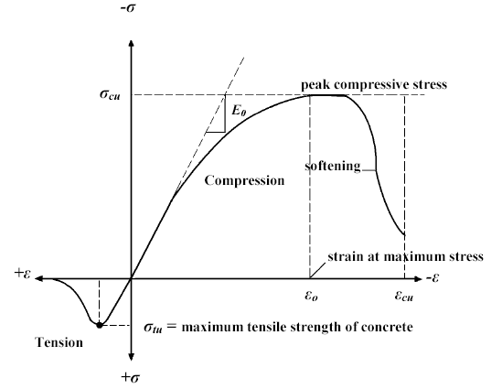
Fig.1 Figure title in English (be placed at the center)
The font in figure is Times New Roman and the size is 9. Physical quantities and units must be coincide with National and International Standards.
Acknowledgements:
Put acknowledgments here if have.

Please list the main references that have already published openly and been cited directly in the paper. The amount of references for last 5 years should occupy more than 50%. References should be arranged by order they appear in the paper.
References(e.g.):
- E.Potter Andrew. Measuring the Orbital Debris Population. Earth Space Review. 1995; 4:21~29.
- T.H. See, M.K. Allbrooks, H.A. Zook, et al. Meteoroid and Debris Impact Features Documented on the Long Duration Exposure Facility. NASA JSC Report # 24608, l990: 561.
- W. Flury. Space Debris Related Activites of ESA. USCOPUOS, S&T SC. February 1995.
- Laurnce, M.R., Brownlee, D.E. The flux of meteoroid and orbital debris striking satellites in low earth orbit. Nature, l986; 323: 136
- H.A. Zook. Deriving the velocity distribution of meteoroids from the measured meteoroid impact directionality on the various LDEF surface, in LDEF –69 Months in Space. First Post-Retrieval Symposium, NASA CP 3134, 1992: 569~580

Biographical notes ZHANG Jiafan, born in 1980, is currently a PhD candidate in State Key Laboratory of Fluid Power Transmission and Control, Zhejiang University, China. He received his bachelor degree from Shanghai Jiaotong University, China, in 2003. His research interests include man-machine system and intelligent robotics. E-mail: caffeezhang@hotmail.com

